
POSTS AND TELECOMMUNICATIONS INSTITUTE OF TECHNOLOGY
FACULTY OF INFORMATION TECHNOLOGY I



INFORMATION SYSTEMS ANALYSIS AND DESIGN
PROJECT REPORT

Supervisor | : Đỗ Thị Bích Ngọc
Student’s name | : Trần Tiến Dũng
Student ID | : B22DCAT054
Class | : E22TTNT
Group | : 06

Hà Nội – 2025

Assignment 08
An online supermarket management system enables management staff, warehouse staff, saler and customer to use:
- Management staff: view the types of statistics: items, suppliers and revenue.
- Warehouse staff: import goods from suppliers, manage (add, delete, change) item information and supplier information, browse online orders and export to delivery staff.
- Saler: selling goods at the counter to customers.
- Customer: register as a member, search, order online, buy directly at the counter.
Considering two modules and answering questions:
- Warehouse staff edits item information: selects the item management menu → selects the function to edit item information → finds items by name to edit → enters item information and clicks edit → the system saves information to the database.
- Customer orders online: choose to order → Repeats the following steps until the end of ordered item: chooses to find items by name → enters quantity → repeats until all items are out, then goes to cart submit → save order.

A. REQUIREMENT
I. Concept exploration
1. Discover term/concepts in the application domain

Actor | Action of actor | Entity/Object
- User  - Management staff  - Warehouse staff  - Saler  - Customer  - Delivery staff | - Login  - Logout  - Management staff view product statistics  - Management staff view supplier statistics  - Management staff view revenue statistics  - Warehouse staff import products from suppliers  - Warehouse staff manage product information  - Warehouse staff manage supplier information  - Warehouse staff browse online orders and export products to delivery staff  - Saler sell products at the counter to customers  - Customer register as a member  - Customer search products  - Customer order online  - Customer buy directly products at the counter | - Product  - Supplier  - Order  - Invoice  - Shopping Cart

2. Build the glossary list

No. | Vietnamese | English | Meanings
Group of concepts related to actor
1 | Người dùng | User | A person who uses the system, has an account and authority to login to the system, and perform functions within the scope of their assigned permissions. There are four account levels: employee accounts, management staff accounts, warehouse staff accounts, saler accounts and customer accounts.
2 | Nhân viên quản lý | Management staff | A person has a management staff account, has the right to use the following functions: viewing the types of statistics: products, suppliers and revenue.
3 | Nhân viên kho | Warehouse staff | A person has a warehouse staff account, has the right to use the following functions: importing products from suppliers, managing (add, delete, change) product information and supplier information, browsing online orders and exporting to delivery staff.
4 | Nhân viên bán hàng | Saler | A person has a saler account, has the right to use the following functions: selling products at the counter to customers.
5 | Khách hàng | Customer | A person has a customer account, can perform the following functions: registering as a member, searching, ordering online, buying directly at the counter.
6 | Nhân viên giao hàng | Delivery staff | A person who receives the printed online orders from the warehouse staff and delivers products to the customer.
Group of concepts related to action of actor
7 | Đăng nhập | Login | Customers or staff log in to the system to use the functions.
8 | Đăng xuất | Logout | Customers or staff log out of the system, ending their session and disconnecting from it.
9 | Xem thống kê mặt hàng | View product statistics | Management staff can view statistical reports about supermarket products.
10 | Xem thống kê nhà cung cấp | View supplier statistics | Management staff can view statistical reports about suppliers.
11 | Xem thống kê doanh thu | View revenue statistics | Management staff can view statistical reports on the supermarket’s revenue.
12 | Nhập hàng | Import products | Warehouse staff receive and store products from suppliers.
13 | Cập nhật thông tin mặt hàng | Manage product information | Warehouse staff add, delete, or update product information in the warehouse.
14 | Cập nhật thông tin nhà cung cấp | Manage supplier information | Warehouse staff add, delete, or update suppliers’ information.
15 | Duyệt đơn đặt hàng trực tuyến và xuất hàng | Browse online orders and export products | Warehouse staff check online orders before exporting products and release the products from the warehouse to the delivery staff.
16 | Bán hàng | Sell products | Saler sells products directly at the counter to customers.
17 | Đăng ký thành viên | Register as a member | Customers create accounts to access the system, enabling them to purchase, search for, and place orders for products.
18 | Tìm kiếm | Search products | Customers can search all products in the supermarket.
19 | Đặt hàng online | Order online | Customers can order online after seeing the products they want.
20 | Mua hàng | Buy products | Customers can buy products directly at the counter.
Group of concepts related to entity/object
21 | Mặt hàng | Product | Products sold in supermarket.
22 | Nhà cung cấp | Supplier | Companies or individuals supplying products to the supermarket.
23 | Đơn hàng | Order | Purchase requests from customers, which can be made online or at the counter.
24 | Hóa đơn | Invoice | Documents recording purchases, including information about the products, prices, and quantities.
25 | Giỏ hàng | Shopping cart | A place where customers temporarily store the products they want to purchase.

II. Business model
1. Description by natural language
1.1. Objective
- An online supermarket management system allows management staff, warehouse staff, saler and customer to use features according to their roles, such as managing products, handling orders, selling at counters, and shopping online.
1.2. Scope
- Type of application: Web application.
- The people who are allowed to access the system (directly use the system) and the functions each of them can perform within the system are defined as follows:
+ User: login, logout.
+ Management staff: can perform the functions of a User, view the types of statistics: products, suppliers and revenue.
+ Warehouse staff: can perform the functions of a User, import products from suppliers, manage (add, delete, change) product information and supplier information, browse online orders and export to delivery staff.
+ Saler: can perform the functions of a User, sell products at the counter to customers.
+ Customer: can perform the functions of a User, register as a member, search products, order online.
- People who can indirectly use the system:
+ Customer: buy directly at the counter.
+ Delivery staff: deliver products directly to customers.
1.3. Operating in each function
- Login: The user opens the system → the system displays the login interface with fields username and password → the user enters their account information → clicks the Login button → The system verifies:
+ If information is missing (left blank) → the system displays an error message and prompts the user to re-enter.
+ If the username or password is incorrect → the system displays the message “Account not found or incorrect password!” and allows the user to try again.
+ If the information is correct → the system authenticates and redirects the user to the main dashboard.
- Logout: The user is on the system’s main interface → selects the Logout function → the system ends the session, clears temporary login information, and redirects the user back to the welcome page.
- Warehouse staff manage product information: Warehouse staff logs in to the system → warehouse staff selects the Product Management menu → warehouse staff chooses Edit function → warehouse staff searches for the product by name → selects the product → enters the updated information and clicks Edit → the system saves the updated information to the database and displays a success message.
- Customer order online: Customer logs in to the system → selects the Order Online option → customer searches for products by name → the system displays a list of products matching the entered keyword → customer selects a product to view details → the system displays detailed information about the product → customer enters the quantity and adds the product to the cart → the system adds the product to the shopping cart → customer repeat the previous steps to add more products if needed → when finished, the customer clicks on the Shopping Cart → the system displays the list of products that have been added to the cart → the customer reviews the products and confirms → the system displays the online invoice → the customer checks it once more and submits → the system saves the invoice to the database and displays a success message.
1.4. Object information in the system
- Group of entities related to actors:
+ User: code, name, username, password, date of birth, address, email, phone number, role.
+ Management staff: same as User.
+ Warehouse staff: same as User.
+ Saler: same as User.
+ Deliver staff: same as User.
+ Customer: same as User.
- Group of entities related to business and operations:
+ Product: code, name, category, stock quantity, price, description.
+ Supplier: code, name, address, phone number, email.
+ Order: date, total price, status (for online order).
+ Invoice: date, total price.
+ Shopping cart.
- Group of entities related to statistics: Product statistics, Supplier statistics, Revenue statistics.
1.5. Relationships among objects
- WarehouseStaff ↔ Invoice (1 - n)
+ A warehouse staff can create many invoices.
- Invoice ↔ Supplier (n - 1)
+ A supplier can be included in many invoices.
- Product ↔ Order (n - n)
+ A product can appear in many orders.
+ An order can include many products.
- Product ↔ Invoice (n - n)
+ A product can appear in many invoices.
+ An invoice can include many products.
- Product ↔ ShoppingCart (n - n)
+ A product can appear in many shopping carts.
+ A shopping cart can include many products.
- Customer ↔ ShoppingCart (1-1)
- Customer ↔ Order (1 - n)
+ A customer can place many orders.
- Order ↔ Invoice (1 - 1)
- Saler ↔ Invoice (1 - n)
+ A saler can create many invoices.
- DeliveryStaff ↔ Invoice (1 - n)
+ A delivery staff can deliver many invoices.

2. Description by UML
2.1. General use case diagram
- Functions corresponding to each actor:
+ User: login.
+ Management staff: view statistics.
+ Warehouse staff: import products, manage product information, manage supplier information, browse online orders and export products.
+ Saler: sell products.
+ Customer: register as a member, search products, order online.
+ Delivery staff: browse online orders and export products.
+ Supplier: import products.

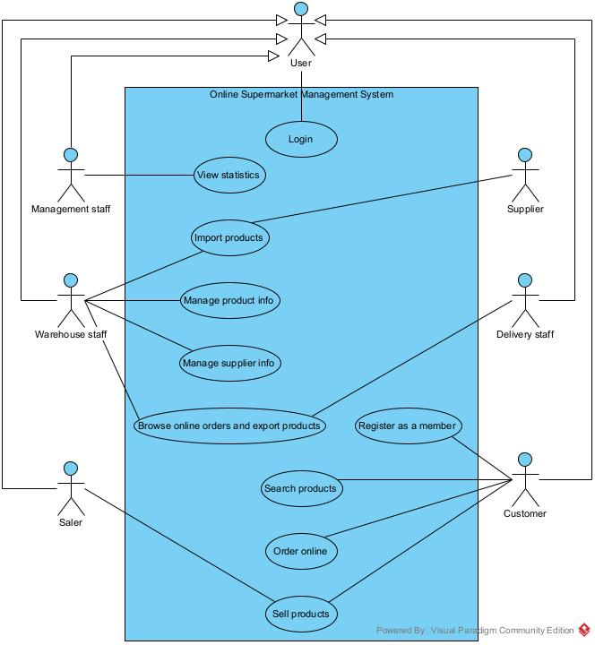

- Use case description:
+ Login: allows user to log into the system.
+ View statistics: allows management staff to view statistical reports on: products, suppliers and revenue.
+ Import products: allows warehouse staff to import products from suppliers into the system.
+ Manage product info: allows warehouse staff to add, edit or delete product details.
+ Manage supplier info: allows warehouse staff to add, edit or delete supplier details.
+ Browse online orders and export products: allows warehouse staff to review online orders and release products to delivery staff.
+ Sell products: allows saler to sell products directly to customers and generate invoices.
+ Register as a member: allows customers to create an account.
+ Search products: allows customers to search for products in the supermarket.
+ Order online: allows customers to place online orders.

2.2. Detail use case diagram
- Detailed use case: Warehouse staff edits item information
( Manage product info )
+ Function Manage product info includes interactive interfaces with warehouse staff:
⦁ Login => proposed UC Login
⦁ Search products => proposed UC Search products
⦁ View product details => proposed UC View product details
⦁ Login, Search products is required for warehouse staff to Manage product information => include relationship.
⦁ View product details is optional => extend relationship.
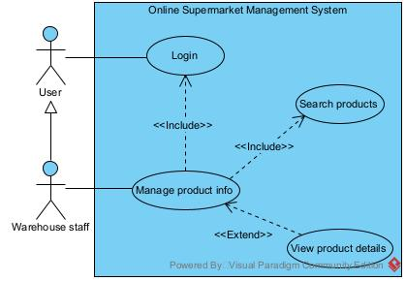
+ Use case description:
⦁ Search products: allows warehouse staff to search for products by name.
⦁ View product details: allows warehouse staff to view detailed information about a product.
- Detailed use case: Customer orders online
( Order online )
+ Function Order online includes interactive interfaces with warehouse staff:
⦁ Login => proposed UC Login
⦁ Search products => proposed UC Search products
⦁ View product details => proposed UC View product details
⦁ View order => proposed UC View order
⦁ Login is required for warehouse staff to Order online => include relationship.
⦁ View order, Search products, View product details is optional => extend relationship.

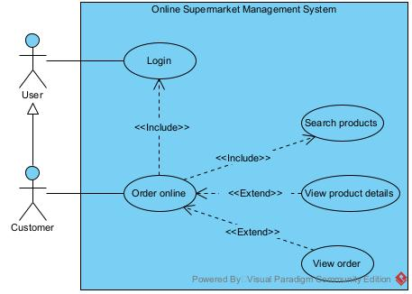

+ Use case description:
⦁ Search products: allows customer to search for products by name.
⦁ View order: allows customer to view a list of products they have purchased along with their quantities.
⦁ View product details: allows customer to view detailed information about a product.

B. ANALYSIS
I. Scenarios
1. Scenario for the module Warehouse staff edits product information
( Manage product info )

Use case | Manage product info
Actor | Warehouse staff
Precondition | Warehouse staff has successfully logged in.
Postcondition | The updated product information is stored in the system database.
Main flow | 1. After logging in, from the main interface, warehouse staff select the Product Management menu.  2. The system displays the list of product management functions.  3. Warehouse staff select Edit Product function.  4. The system displays the Edit Product interface.  Edit Product  Search  Back  5. Warehouse staff enter the product name: “iPhone 17” to edit and click Search.  Edit Product  iPhone 17 Search  Back  6. The system displays a list of matching products.  Edit Product  iPhone 17  Search  No. Product name Category Stock quantity Price ($)  1 iPhone 17 Smartphone 20 799 $  2 iPhone 17 Pro Smartphone 10 1 099 $  3 iPhone 17 Pro Max Smartphone 15 1 199 $  7. Warehouse staff clicks on the product name “iPhone 17” in the search result table.  8. The system displays the Edit Product Details interface.  9. Warehouse staff edit the Name field from “iPhone 17” to “iPhone 17 - fake” and the Price field from 799 to 800.  Edit Product Details  - Code: SMP001  - Name: iPhone 17 - fake  - Category: Smartphone  - Stock quantity: 20  - Price: 800 $  - Description: The iPhone 17 features a sleek titanium design, a faster A19 Bionic chip, and an improved battery life that lasts all day.  Save Cancel  10. Warehouse staff click Save.  11. The system saves the changes into the database, displays a success message: “Update product successfully!”.
Exception | 6. No product matches the search name.

2. Scenario for the module Customer orders online
( Order online )

Use case | Order online
Actor | Customer
Precondition | The customer has successfully logged into the online supermarket management system.
Postcondition | A new order is created and stored in the system database.
Main flow | 1. After logging in, from the main interface, the customer selects the Online Order function.  2. The system displays the Online Order interface.  Online Order  Shopping Cart  Search  Back  3. The customer searches for “iPhone 17”.  4. The system displays a list of matching products.  Online Order  Shopping Cart  iPhone 17 Search  No. Product name Category Stock quantity Price ($)  1 iPhone 17 Smartphone 20 799 $  2 iPhone 17 Pro Smartphone 10 1 099 $  3 iPhone 17 Pro Max Smartphone 15 1 199 $  Back  5. The customer clicks on the product name “iPhone 17” in the search result table.  6. The system displays the Product Details interface.  Product details  - Code: SMP001  - Name: iPhone 17  - Category: Smartphone  - Stock quantity: 20  - Price: 799 $  - Description: The iPhone 17 features a sleek titanium design, a faster A19 Bionic chip, and an improved battery life that lasts all day.  Quantity: Add to Cart  Back  7. The customer reviews the product information, enters the desired quantity “2”, and clicks Add to Cart.  8. The system adds the selected product and quantity to the customer’s shopping cart.  9. The customer clicks Back.  10. The system returns to the Online Order interface.  11. The customer may repeat steps 3 → 10 until all desired products are selected.  12. The customer clicks the Shopping Cart.  13. The system displays the Shopping Cart interface.  Shopping Cart  No. Product name Quantity Unit price Total  1 iPhone 17 2 799 $ 1 598 $  2 ASUS Vivobook 1 349 $ 349 $  Total Amount: 1 947 $  Submit  14. The customer reviews the products and then clicks Submit.  15. The system displays the Invoice interface.  Invoice  - Name: Tran Tien Dung  - Phone number: 0987654321  - Address: Long Bien, Ha Noi  - Order date: 28/09/2025  - List of products:  No. Product name Quantity Price  1 iPhone 17 2 1 598 $  2 ASUS Vivobook 1 349 $  Total: 1 947 $  Confirm  16. The customer reviews the invoice and clicks Confirm.  17. The system saves the invoice into the database and displays a success message: “Order placed successfully”.
Exception | 4. No product matches the search name.

II. Entity class extraction
- Step 1: Describe the system in a paragraph
A supermarket management system allows management staff, warehouse staff, saler, and customer to use it. After logging in, the actors (customer or employee) can perform the following actions: Management staff: view the types of statistics: items, suppliers and revenue. Warehouse staff: import goods from suppliers, manage (add, delete, change) item information and supplier information, browse online orders and export to delivery staff. Saler: selling goods at the counter to customers. Customer: register as a member, search, order online, buy directly at the counter.

- Step 2: Extract the nouns that appear in the paragraph
+ Nouns related to people: User, Management staff, Warehouse staff, Saler, Customer, Delivery staff.
+ Nouns related to objects: Product, Order, Invoice, Shopping cart.
+ Nouns related to information: Supplier, Product statistics, Supplier statistics, Revenue statistics.

- Step 3: Evaluate and select the nouns to be entity classes or attributes
+ Nouns related to people:
● User → User (abstract): code, name, username, password, date of birth, address, email, phone number, role.
● Management staff → ManagementStaff: inherits from class User.
● Warehouse staff → WarehouseStaff: inherits from class User.
● Saler → Saler: inherits from class User.
● Delivery staff → DeliveryStaff: inherits from class User.
● Customer → Customer: inherits from class User.
+ Nouns related to objects:
● Product → Product: code, name, category, price, stock quantity, description.
● Order → proposed class Order: order date, total price, status.
● Invoice → proposed class OnlineInvoice: export date.
૦ proposed additional class OfflineInvoice: purchase date, total price.
૦ proposed additional class ImportInvoie: import date, total price.
● Shopping cart → ShoppingCart.

+ Nouns related to information:
● Supplier → Supplier: code, name, address, phone number, email.
● Product statistics → ProductStat.
● Supplier statistics → SupplierStat.
● Revenue statistics → RevenueStat.

- Step 4: Determine the cardinality between entities
+ One Customer can have many Order, but one Order can only belong to one Customer. → This is a 1-n relationship between Customer and Order.
+ The relationship between Order and OnlineInvoice is 1-1.
+ The relationship between Product and Order is n-n because one Product can belong to many Order, and one Order can contain many Product. → Proposed class OrderProductDetail uniquely identifies one Product belonging to a specific Order.
+ The relationship between Customer and ShoppingCart is 1-1.
+ One DeliveryStaff can deliver many OnlineInvoice, but one OnlineInvoice can only have one DeliveryStaff responsible for the delivery. → This is a 1-n relationship between DeliveryStaff and OnlineInvoice.
+ One WarehouseStaff can create many OnlineInvoice, but one OnlineInvoice can only be created by one WarehouseStaff. → This is a 1-n relationship between WarehouseStaff and OnlineInvoice.
+ One WarehouseStaff can create many ImportInvoice, but one ImportInvoice can only be created by one WarehouseStaff. → This is a 1-n relationship between WarehouseStaff and ImportInvoice.
+ One Supplier can be associated with many ImportInvoice, but one ImportInvoice can only be associated with one Supplier. → This is a 1-n relationship between Supplier and ImportInvoice.
+ The relationship between Product and ShoppingCart is n-n because one Product can belong to many ShoppingCart, and one ShoppingCart can contain many Product. → Proposed class ShoppingCartProductDetail uniquely identifies one Product belonging to a specific ShoppingCart.
+ One Saler can process many OfflineInvoice, but one OfflineInvoice can only belong to one Saler. → This is a 1-n relationship between Saler and OfflineInvoice.

+ The relationship between OfflineInvoice and Product is n-n because one OfflineInvoice can contain many Product, and one Product can belong to many OfflineInvoice. → Proposed class OfflineProductDetail uniquely identifies one Product belonging to a specific OfflineInvoice.
+ The relationship between ImportInvoice and Product is n-n because one Product can belong to many ImportInvoice, and one ImportInvoice can contain many Product. → Proposed class ImportProductDetail uniquely identifies one Product belonging to a specific ImportInvoice.

- Step 5: Identify the object relationships between entities
+ ShoppingCart and Product combine to create a unique ShoppingCartProductDetail.
+ Order and Product combine to create a unique OrderProductDetail.
+ OfflineInvoice and Product combine to create a unique OfflineProductDetail.
+ ImportInvoice and Product combine to create a unique ImportProductDetail.
+ Information about Customer is contained in Order.
+ Information about Order is contained in OnlineInvoice.
+ Information about WarehouseStaff is contained in OnlineInvoice.
+ Information about WarehouseStaff is contained in ImportInvoice.
+ Information about DeliveryStaff is contained in OnlineInvoice.
+ Information about Saler is contained in OfflineInvoice.
+ Information about Supplier is contained in ImportInvoice.

- Entity class diagram of the SYSTEM:
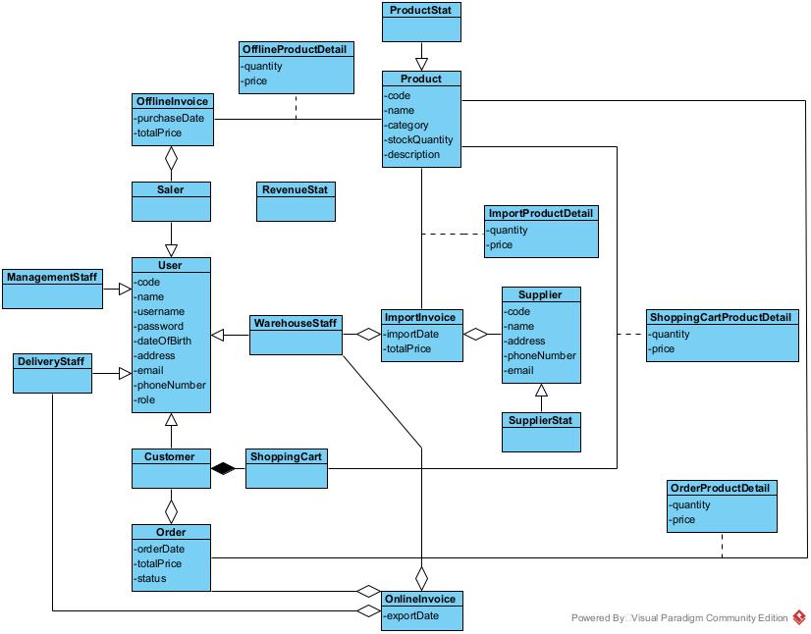

III. State diagram
1. Module manage product information
- Describes the operation of the module:
● From the main warehouse staff interface, if the Product Management function is selected, the system switches to the Product Management Functions list.
● From the Product Management Functions list, if Edit Product is selected, the system switches to the Edit Product interface.
● At the Edit Product interface, after the product name is entered and Search is clicked, the system displays a list of matching products.
● From the list of matching products, if a product name is selected, the system switches to the Edit Product Detail interface.
● From the Edit Product Details interface, after editing and clicking Save, the system saves the updated information and ends.

- State diagram for the module:
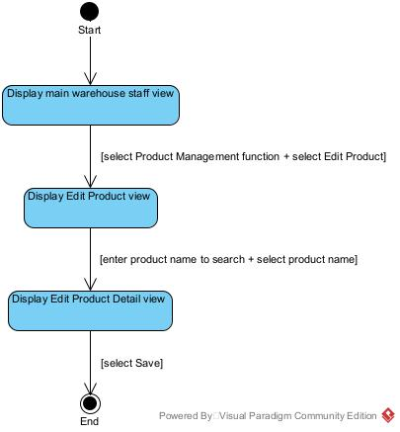

2. Module order online
- Describes the operation of the module:
● From the main customer interface, if the Online Order function is selected, the system displays the Online Order interface.
● At the Online Order interface, after entering a product name and clicking Search, the system displays a list of matching products.
● From the list of matching products, if a product name is selected, the system switches to the Product Detail view.
● At the Product Detail view, after entering the quantity, adding to cart and clicking Back, the system returns to the Online Order interface. If more products are selected, the process repeats; otherwise, clicking Shopping Cart to display the Shopping Cart interface.
● At the Shopping Cart interface, after clicking submit, the system displays the Invoice interface.
● At the Invoice interface, after clicking Confirm, the system saves the invoice and ends.

- State diagram for the module:
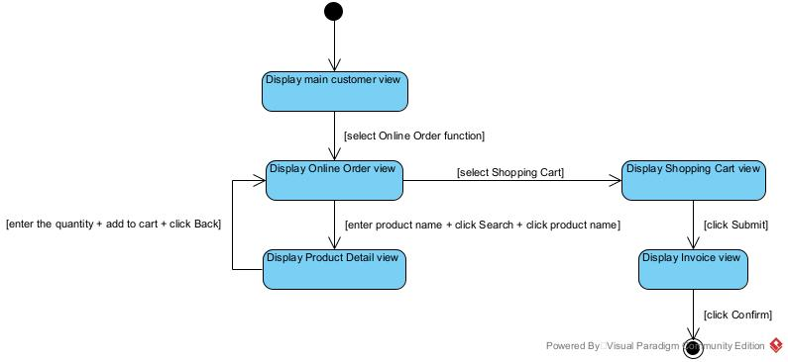

IV. Module class diagram
1. Static Analysis for the Manage Product Information module
- Initially, the main interface of the warehouse staff → propose class MainWSView, requiring the following components:
● select Product Management function: type submit, output.
● select Edit Product: type submit.
- Step 2, Edit Product interface → proposed class EditProductView, requiring the following components:
● enter a product name to search: type input.
● select Search: type submit.
● return a list of matching products: type output.
● select a product name in the list: type submit.
- System-side processing for Step 2:
● Retrieve the list of matching products.
● Input: search keyword.
● Output: list of products.
● Proposed method: getProductByName(), assigned to class Product.
- Step 4, Edit Product Detail view → proposed class EditProductDetailView, requiring the following components:
● return the product information: type output.
● enter updated information: type input.
● click Save: type submit.

- System-side processing for Step 4:
● Retrieve the information of the product.
● Input:
● Output: information of product.
● Proposed method: getProductDetail(), assigned to class Product.
- System-side processing for Step 4:
● Save edited product information.
● Input: updated product information.
● Output: product information after updating.
● Proposed method: updateProductInfor(), assigned to class Product.
=> Result:
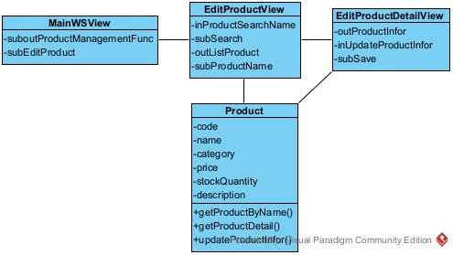

2. Static Analysis for the Order Online module
- Initially, the main interface of the customer → propose class MainCustomerView, requiring the following components:
● select Online Order function: type submit.
- Step 2, Online Order interface → proposed class OnlineOrderView, requiring the following components:
● enter a product name to search: type input.
● click Search: type submit.
● return a list of matching products: type output.
● select a product name in the list: type submit.
● click Shopping Cart: type submit.

- System-side processing for Step 2:
● retrieve the list of matching products.
● Input: search keyword.
● Output: list of products.
● Proposed method: getProductByName(), assigned to class Product.
- Step 4, Product Detail View → proposed class ProductDetailView, requiring the following components:
● return the product information: type output.
● enter quantity: type input.
● click Add to Cart: type submit.
● click Back: type submit.
- System-side processing for Step 4:
● retrieve the information of the product.
● input:
● output: information of product.
● Proposed method: getProductDetail(), assigned to class Product.
- System-side processing for Step 4:
● add selected product and quantity to the shopping cart.
● input: selected product and quantity.
● output:
● Proposed method: addToCart(), assigned to class ShoppingCart.
- Step 6, Shopping Cart interface → proposed class ShoppingCartView, requiring the following components:
● return a list of products in the shopping cart: type output.
● click Submit: type submit.
- System-side processing for Step 6:
● retrieve the list of products in the shopping cart.
● input:
● output: list of products.
● Proposed method: getListProductInCart(), assigned to class Shopping Cart.
- Step 8, Invoice interface → proposed class InvoiceView, requiring the following components:
● return an invoice: type output.
● click Confirm: type submit.

- System-side processing for Step 8:
● retrieve the invoice.
● input:
● output: invoice.
● Proposed method: getInvoice(), assigned to class Order.
- System-side processing for Step 8:
● save the invoice.
● input: the invoice confirmed by the customer.
● output: a success message.
● Proposed method: saveInvoice(), assigned to class Order.
=> Result:
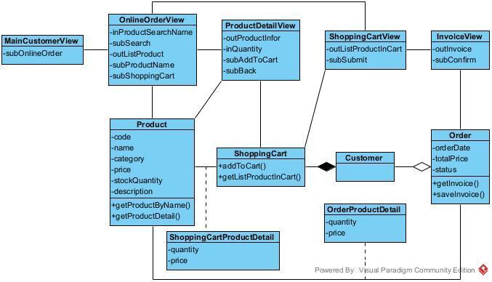
V. Sequence/communication diagram
1. Module Manage product information
a. Scenario v.2
1. After logging in, from the main interface, warehouse staff select the Product Management menu.
2. The MainWSView class displays the list of product management functions.
3. Warehouse staff selects Edit Product function.
4. The MainWSView class calls the EditProductView.
5. Warehouse staff enter the product name and click Search.
6. The EditProductView class calls the Product class to retrieve matching products.
7. The Product class retrieves the matching products from the database.
8. The EditProductView class displays the list of matching products to the warehouse staff.
9. Warehouse staff clicks on a product name in the search result table.
10. The EditProductView class calls the EditProductDetailView class.
11. The EditProductDetailView class calls the Product class to retrieve information about product.
12. The Product class retrieves the information about the product from the database.
13. The EditProductDetailView class displays the information about the product to the warehouse staff.
14. Warehouse staff edit the information of the product and click Save.
15. The EditProductDetailView class calls the Product class to update the information about the product.
16. The Product class saves the changes into the database.
17. The EditProductView displays a successful update message.

b. Communication diagram
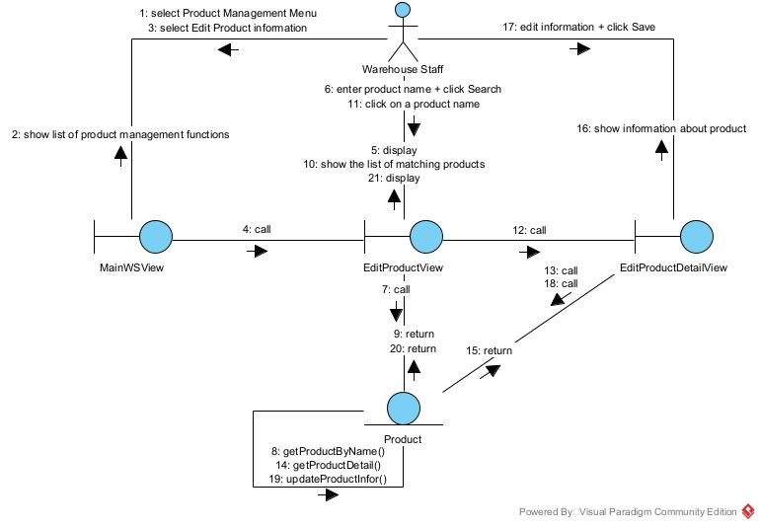

c. Sequence diagram
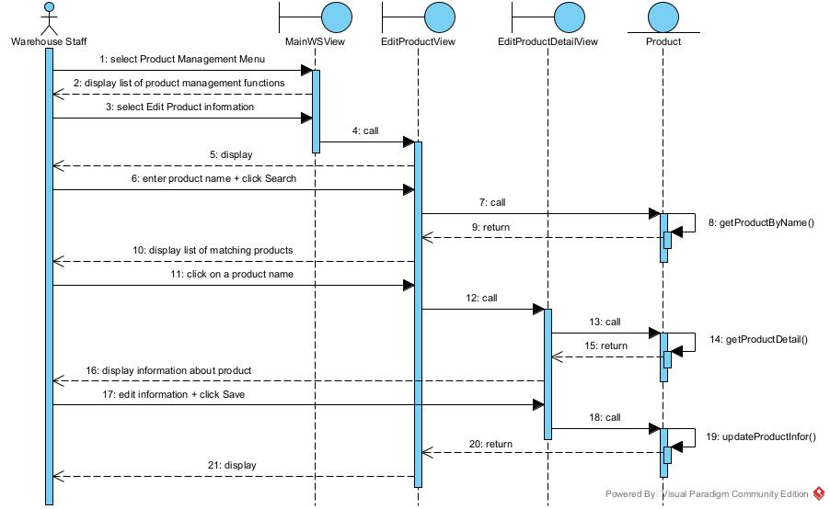

2. Module Order Online
a. Scenario v.2
1. After logging in, from the main interface, the customer selects the Online Order function.
2. The MainCustomerView class calls the OnlineOrderView class.
3. The customer searches for the product by name.
4. The OnlineOrderView class calls the Product class to retrieve matching products.
5. The Product class retrieves the matching products from the database.
6. The OnlineOrderView class displays the list of matching products to the customer.
7. The customer clicks on a product name in the result list.
8. The OnlineOrderView class calls the ProductDetailView class.
9. The ProductDetailView class calls the Product class to retrieve information about product.
10. The Product class retrieves the information about the product from the database.
11. The ProductDetailView class displays the information about the product to the customer.
12. The customer reviews the product information, enters quantity, and clicks Add to Cart.
13. The ProductDetailView class calls the ShoppingCart class to add the selected product and quantity.
14. The ShoppingCart class saves to the database.
15. Customer clicks Back.
16. The ProductDetailView class calls the OnlineOrderView class.
17. The OnlineOrderView class displays again to the customer. (Repeat steps 3-17 until the customer has selected all desired products.)
18. The customer clicks the Shopping Cart.
19. The OnlineOrderView class calls the ShoppingCartView.
20. The ShoppingCartView class calls the ShoppingCart class.
21. The ShoppingCart class retrieves the list of the products that the customer added to the cart in step 12.
22. The ShoppingCartView class displays the list of products to the customer.
23. The customer clicks Submit.
24. The ShoppingCartView class calls the InvoiceView class.
25. The InvoiceView class calls the Order class.
26. The Order class queries the database to retrieve the invoice.
27. The InvoiceView class displays the invoice information.
28. The customer reviews the invoice and clicks Confirm.
29. The InvoiceView class calls the Order class.
30. The Order class saves the invoice into the database.
31. The MainCustomerView displays a success message.

b. Communication diagram
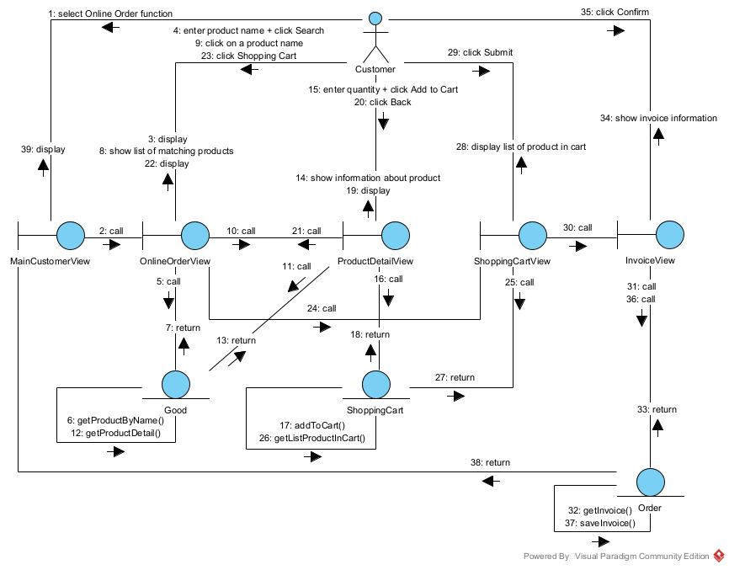

c. Sequence diagram
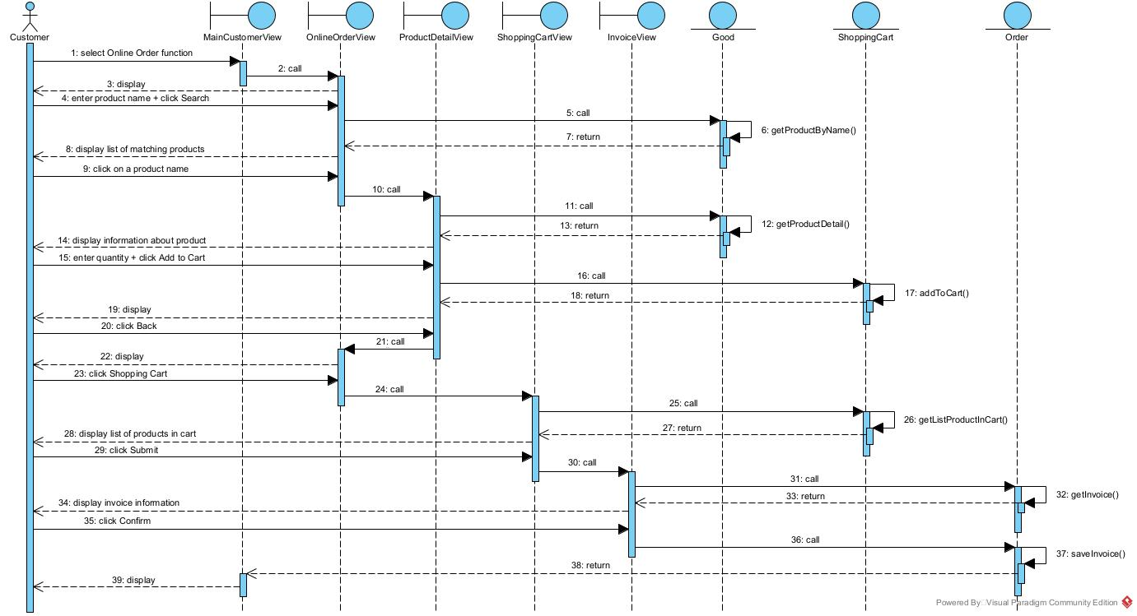

C. DESIGN
I. Entity class diagram
- Step 1: The classes are supplemented with the attribute id, except for the classes Customer, ManagementStaff, WarehouseStaff, Saler, DeliveryStaff, ProductStat, SupplierStat, RevenueStat.
- Step 2: The attributes of the classes are supplemented with data types according to the Java programming language.
- Step 3:
+ The relationship OfflineInvoice - Product → OfflineProductDetail is transformed into OfflineProductDetail containing Product, and OfflineInvoice containing OfflineProductDetail.
+ The relationship ImportInvoice - Product → ImportProductDetail is transformed into ImportProductDetail containing Product, and ImportInvoice containing ImportProductDetail.
+ The relationship ShoppingCart - Product → ShoppingCartProductDetail is transformed into ShoppingCartProductDetail containing Product, and ShoppingCart containing ShoppingCartProductDetail.
+ The relationship Order - Product → OrderProductDetail is transformed into OrderProductDetail containing Product, and Order containing OrderProductDetail.
- Step 4: Adding component attributes of aggregation/composition relationships.

=> Entity class diagram:
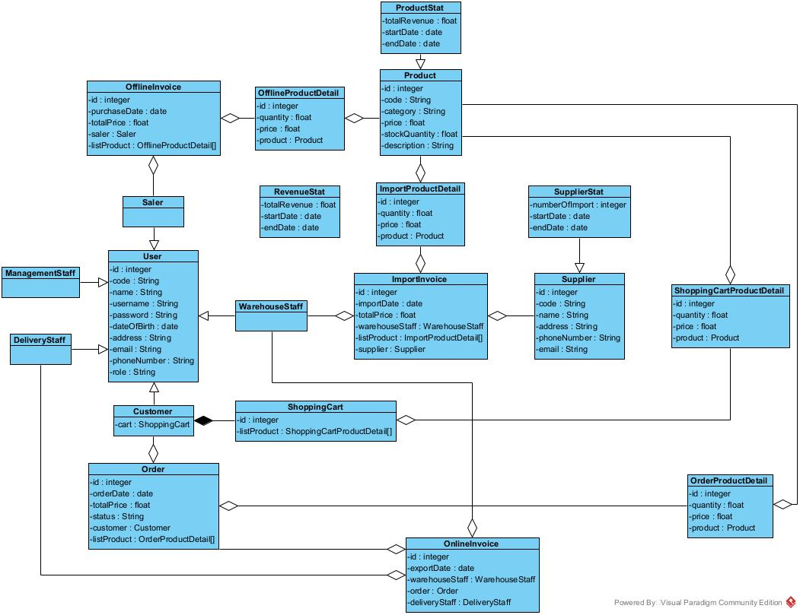

II. Database
- Step 1: Each entity class corresponds to a table:
+ Class User → table tblUser.
+ Class Customer → table tblCustomer.
+ Class OfflineInvoice → table tblOfflineInvoice.
+ Class OfflineProductDetail → table tblOfflineProductDetail.
+ Class Product → table tblProduct.
+ Class ImportProductDetail → table tblImportProductDetail.
+ Class ImportInvoice → table tblImportInvoice.
+ Class Order → table tblOrder.
+ Class OrderProductDetail → table tblOrderProductDetail.
+ Class ShoppingCart → table tblShoppingCart.
+ Class OnlineInvoice → table tblOnlineInvoice.
+ Class Supplier → table tblSupplier.
+ Class ShoppingCartProductDetail → table tblShoppingCartProductDetail.
- Step 2: Convert non-object attributes of entity classes into attributes of the corresponding tables:
+ tblUser has the following attributes: id, code, name, username, password, dateOfBirth, address, email, phoneNumber, role.
+ tblCustomer.
+ tblOfflineInvoice: id, purchaseDate.
+ tblOfflineProductDetail: id, quantity, price.
+ tblProduct: id, code, name, category, stockQuantity, description.
+ tblImportInvoice: id, importDate.
+ tblImportProductDetail: id, quantity.
+ tblSupplier: id, code, name, address, email, phoneNumber.
+ tblShoppingCart: id.
+ tblOrder: id, orderDate, status.
+ tblOrderProductDetail: id, quantity, price.
+ tblOnlineInvoice: id, exportDate.
+ tblShoppingCartProductDetail: id, quantity, price.
- Step 3: Transform cardinality relationships between entity classes into corresponding relationships between tables:
+ 1 tblUser - 1 tblCustomer.
+ 1 tblUser - n tblOfflineInvoice.
+ 1 tblOfflineInvoice - n tblOfflineProductDetail.
+ 1 tblOfflineProductDetail - 1 tblProduct.
+ 1 tblProduct - 1 tblImportProductDetail.
+ 1 tblImportInvoice - n tblImportProductDetail.
+ 1 tblUser - n tblImportInvoice.
+ 1 tblImportInvoice - 1 tblSupplier.
+ 1 tblUser - n tblOnlineInvoice.
+ 1 tblCustomer - 1 tblShoppingCart.
+ 1 tblCustomer - n tblOrder.
+ 1 tblShoppingCart - n tblShoppingCartProductDetail.
+ 1 tblOrder - n tblOrderProductDetail.
+ 1 tblProduct - 1 tblOrderProductDetail.
+ 1 tblOrder - n tblOnlineInvoice.
+ 1 tblProduct - 1 tblShoppingCartProductDetail.

- Step 4:
+ Add key attributes. The primary key is assigned to the id attribute of each corresponding table, except for the following tables: tblCustomer.
+ Foreign keys are established for the following relationships:
● 1 tblUser - 1 tblCustomer → tblCustomer has a foreign key tblUserid.
● 1 tblUser - n tblOfflineInvoice → tblOfflineInvoice has a foreign key tblUserid.
● 1 tblOfflineInvoice - n tblOfflineProductDetail → tblOfflineProductDetail has a foreign key tblOfflineInvoiceid.
● 1 tblOfflineProductDetail - 1 tblProduct → tblOfflineProductDetail has a foreign key tblProductid.
● 1 tblProduct - 1 tblImportProductDetail → tblImportProductDetail has a foreign key tblProductid.
● 1 tblImportInvoice - n tblImportProductDetail → tblImportProductDetail has a foreign key tblImportInvoiceid.
● 1 tblUser - n tblImportInvoice → tblImportInvoice has a foreign key tblUserid.
● 1 tblImportInvoice - 1 tblSupplier → tblImportInvoice has a foreign key tblSupplierid.
● 1 tblUser - n tblOnlineInvoice → tblOnlineInvoice has a foreign key tblUserid.
● 1 tblCustomer - 1 tblShoppingCart → tblShoppingCart has a foreign key tblCustomerUserid.
● 1 tblCustomer - n tblOrder → tblOrder has a foreign key tblCustomerUserid.
● 1 tblShoppingCart - n tblShoppingCartProductDetail → tblShoppingCartProductDetail has a foreign key tblShoppingCartid.
● 1 tblOrder - n tblOnlineInvoice → tblOnlineInvoice has a foreign key tblOrderid.
● 1 tblProduct - 1 tblShoppingCartProductDetail → tblShoppingCartProductDetail has a foreign key tblProductid.
● 1 tblOrder - n tblOrderProductDetail → tblOrderProductDetail has a foreign key tblOrderid.
● 1 tblProduct - 1 tblOrderProductDetail → tblOrderProductDetail has a foreign key tblProductid.

- Step 5: Derived attributes:
+ totalPrice in table tblOfflineInvoice, tblImportInvoice.
+ All attributes of statistical classes → remove all corresponding statistical tables.
=> Database of the system:
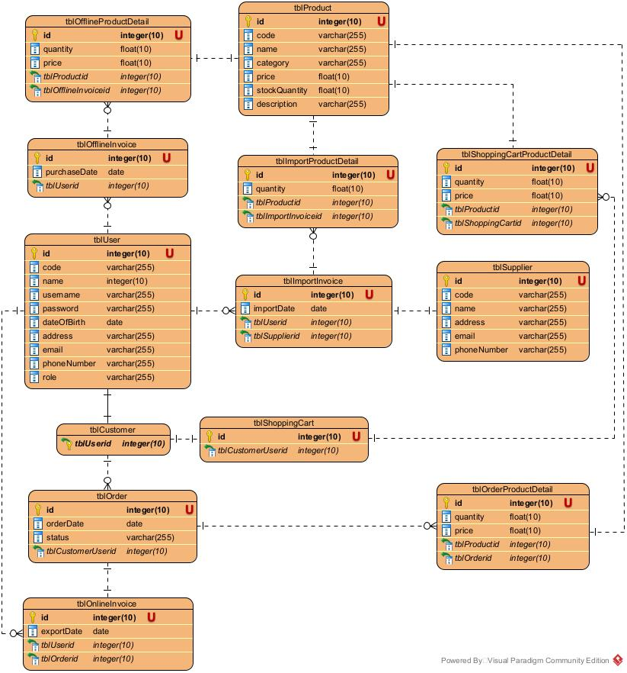

III. Design of interface
1. Module Management Good Information
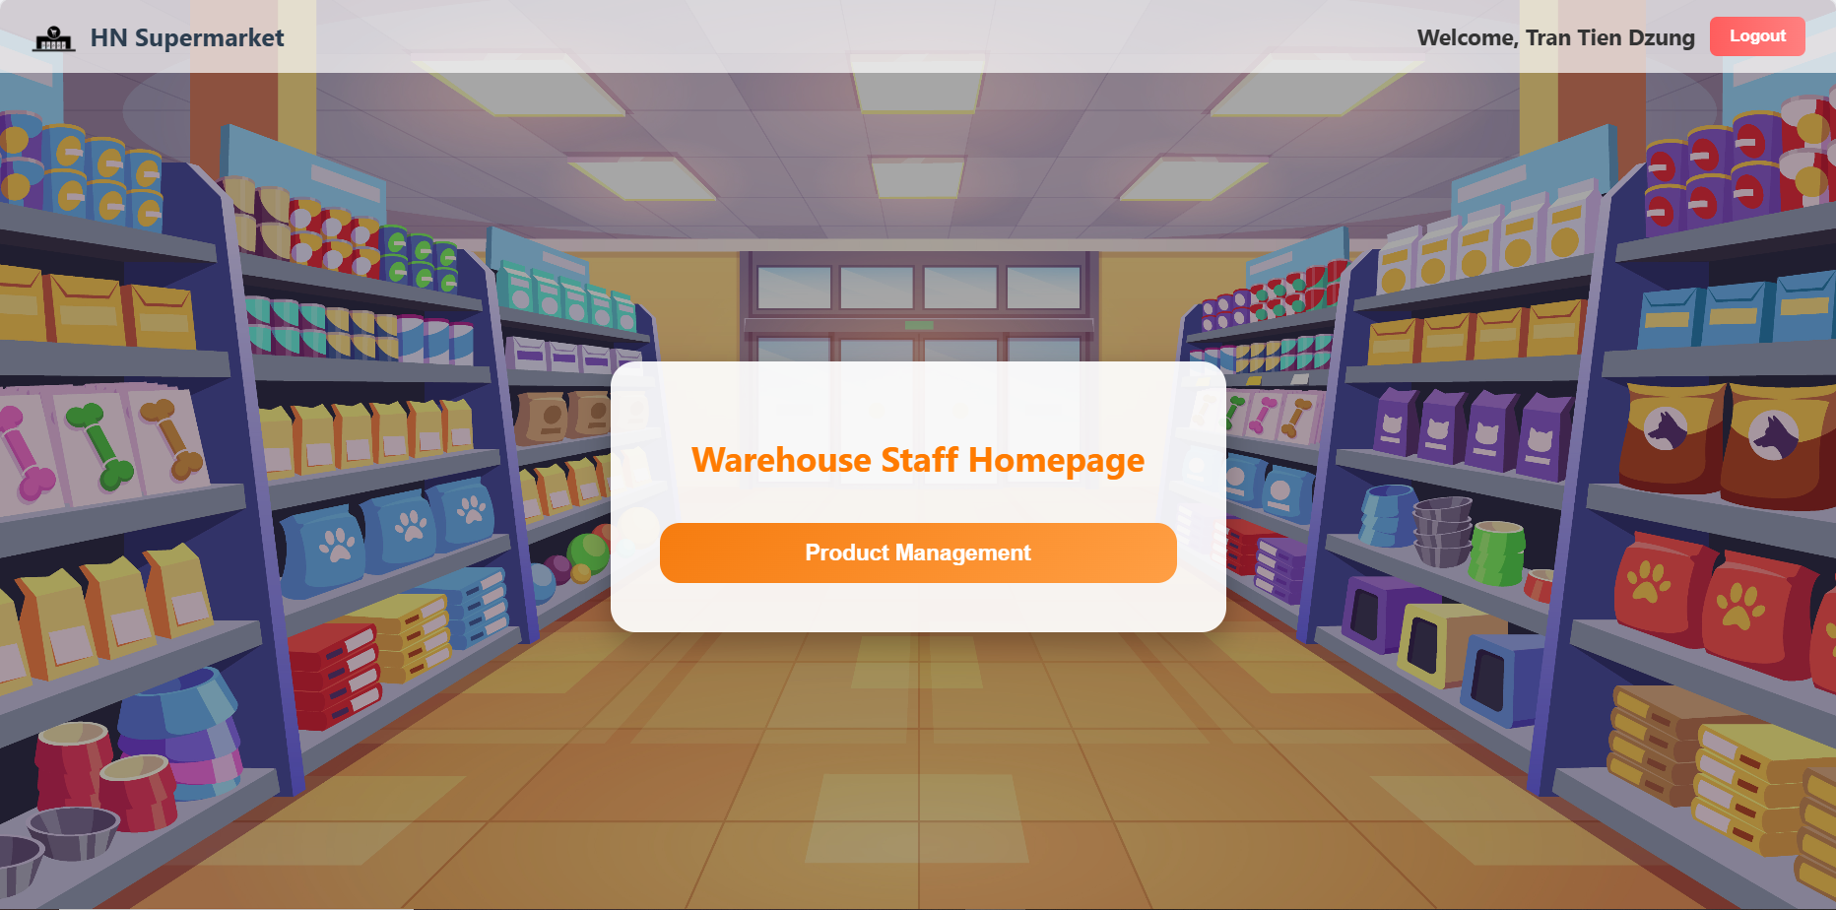
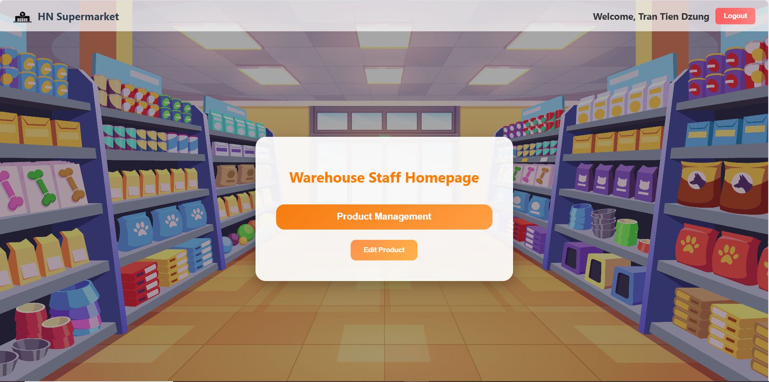
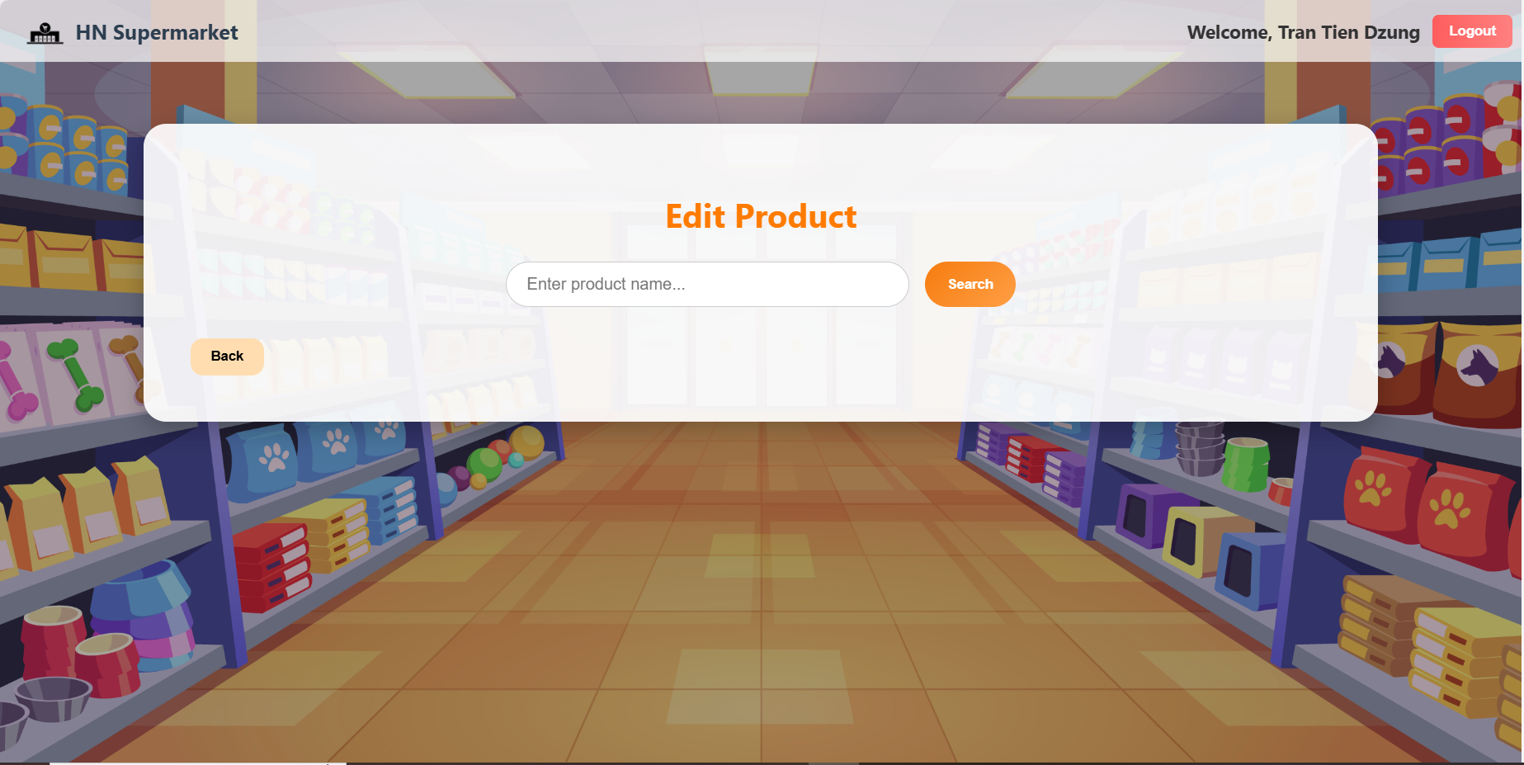
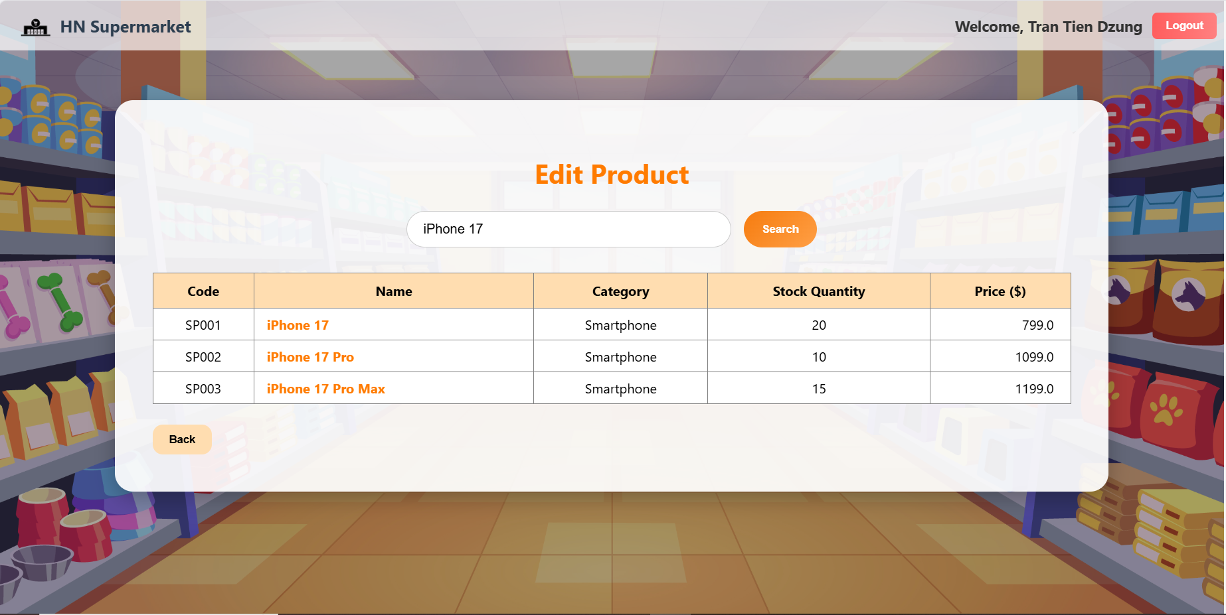
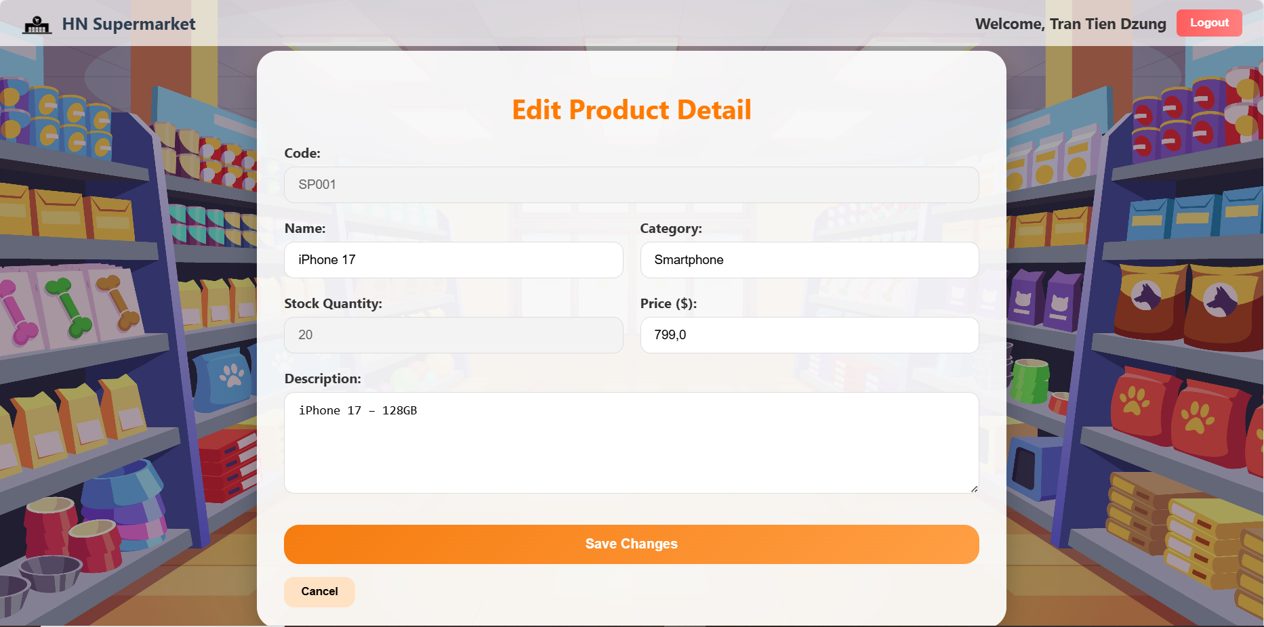
2. Module Order Online
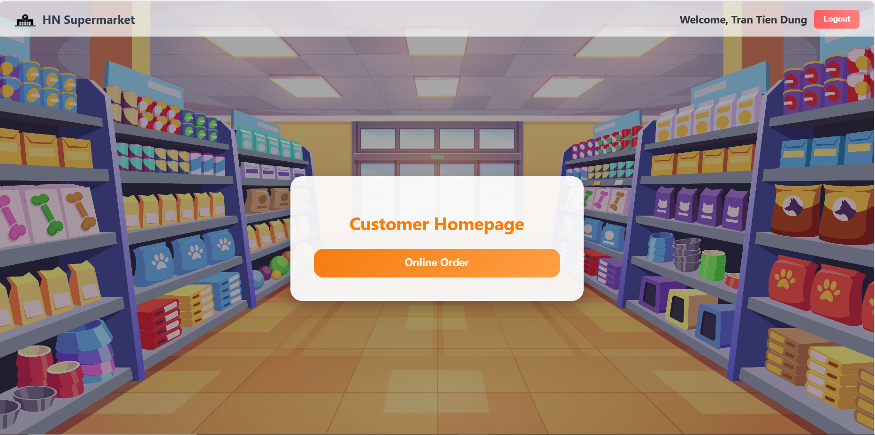
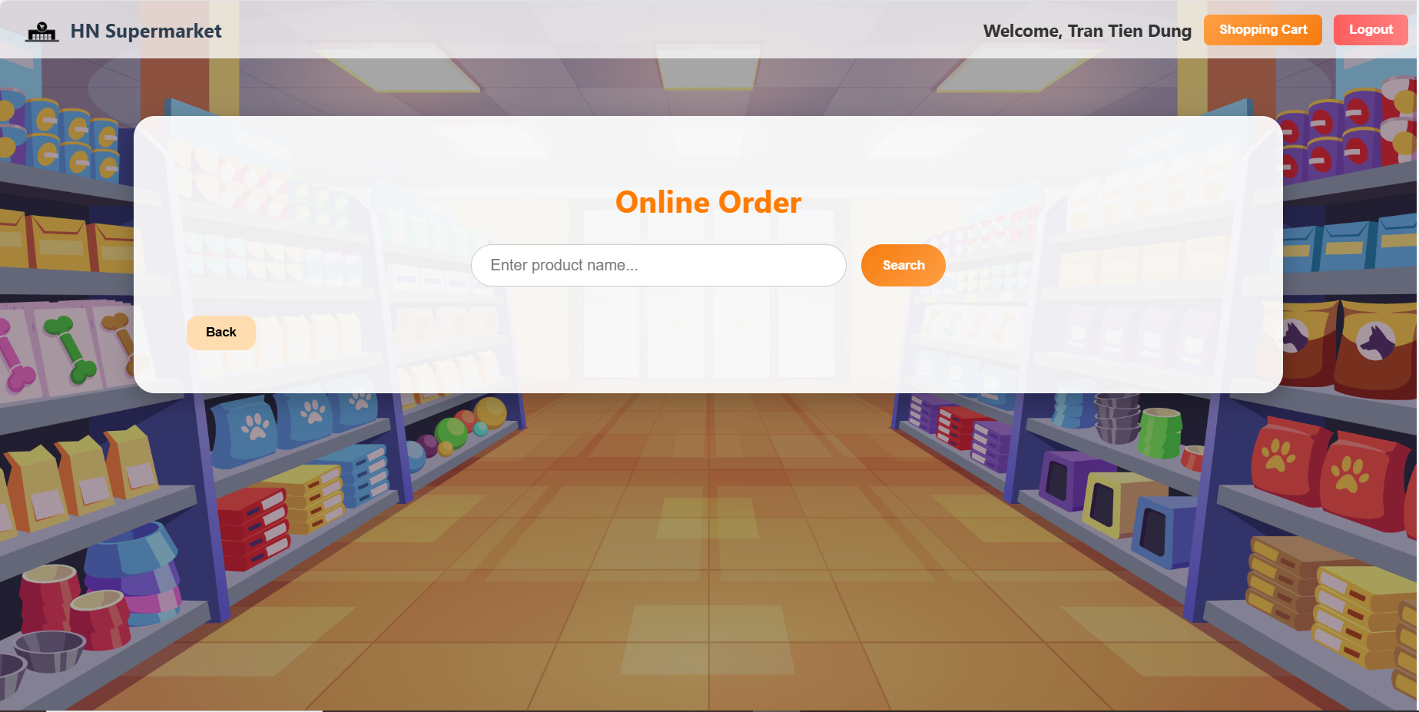
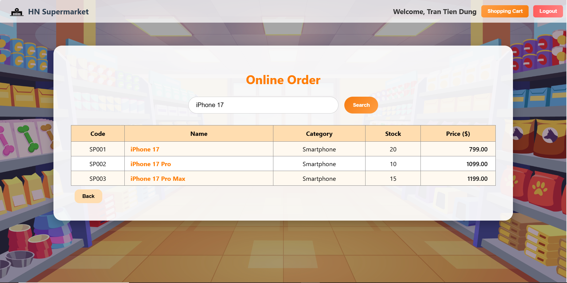
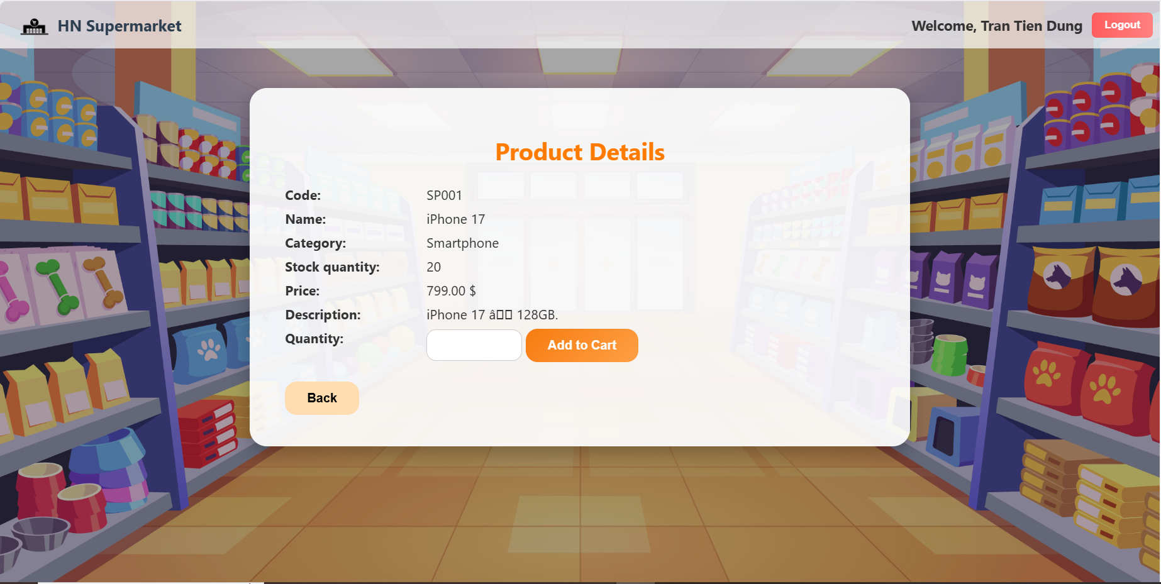
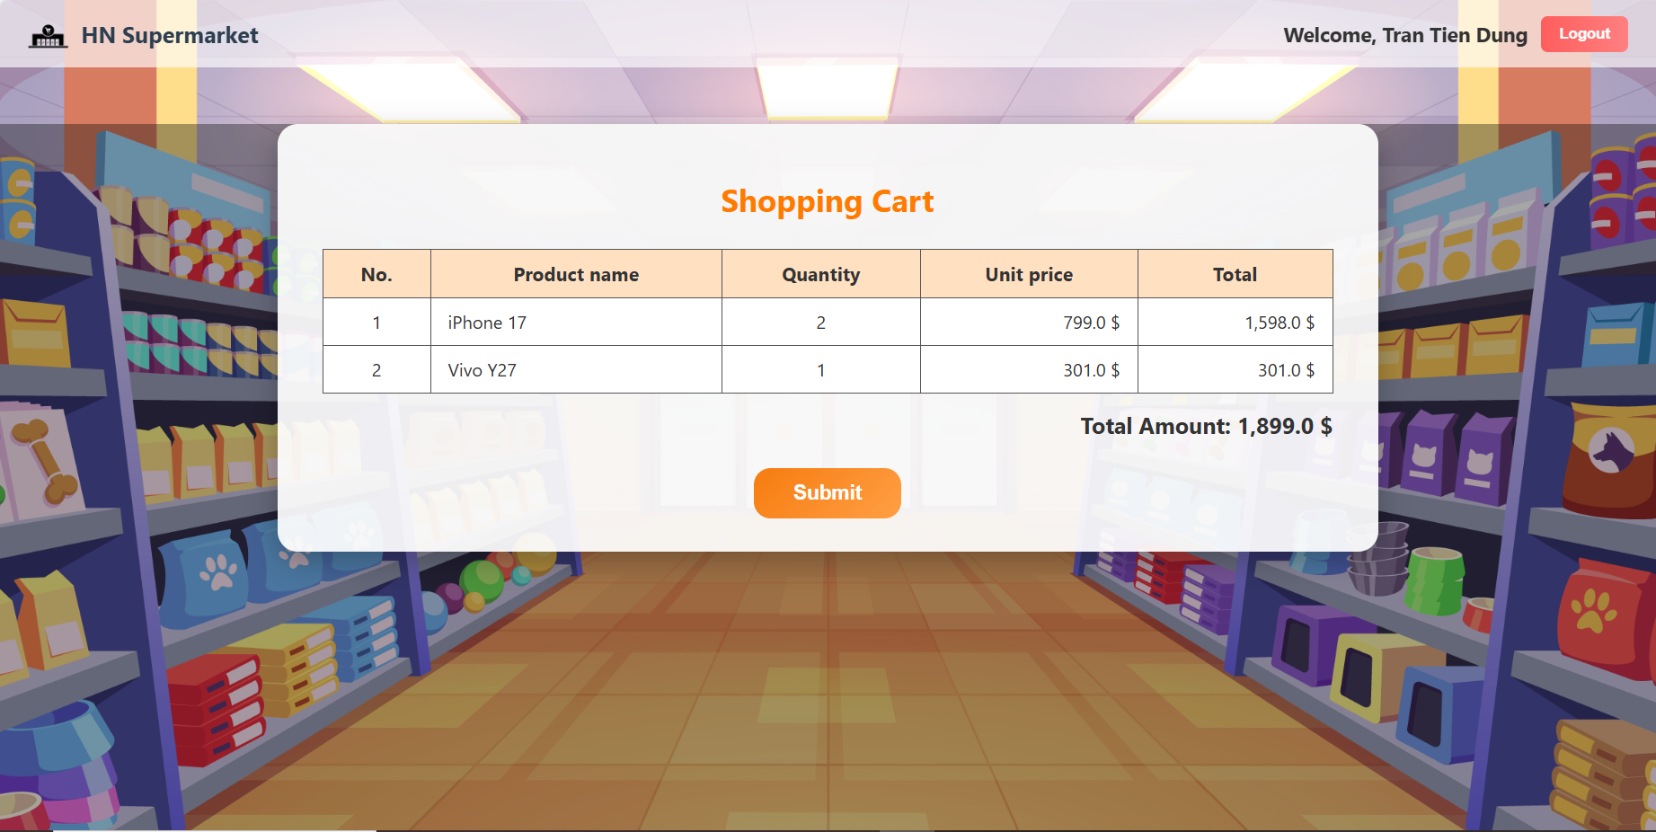
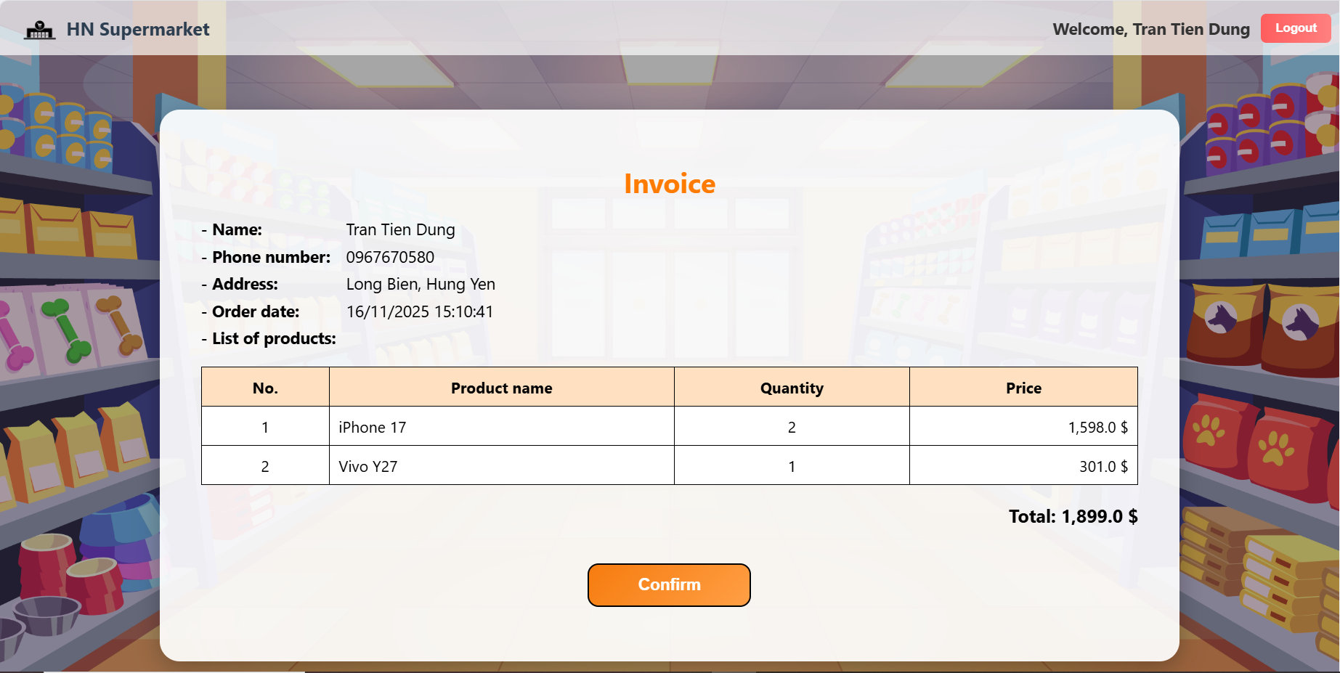

IV. Class diagram of module
1. Module Management Good Information
- The presentation layer includes the jsp pages: MainWSView.jsp, EditProductView.jsp, EditProductDetailView.jsp.
- The controller layer includes the controller pages: ProductController.
- The data access layer contains the DAO classes: DAO, ProductDAO.
- The entity layer includes all related entities.
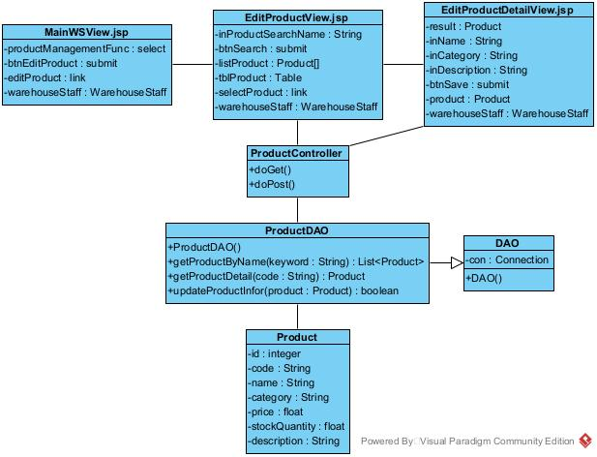

2. Module Order Online
- The presentation layer includes the jsp pages: MainCustomerView.jsp, OnlineOrderView.jsp, ProductDetailView.jsp, ShoppingCartView.jsp, InvoiceView.jsp.
- The controller layer includes the controller pages: ProductController, ShoppingCartController, OrderController.
- The data access layer contains the DAO classes: DAO, ProductDAO, ShoppingCartDAO, OrderDAO.
- The entity layer includes all related entities.
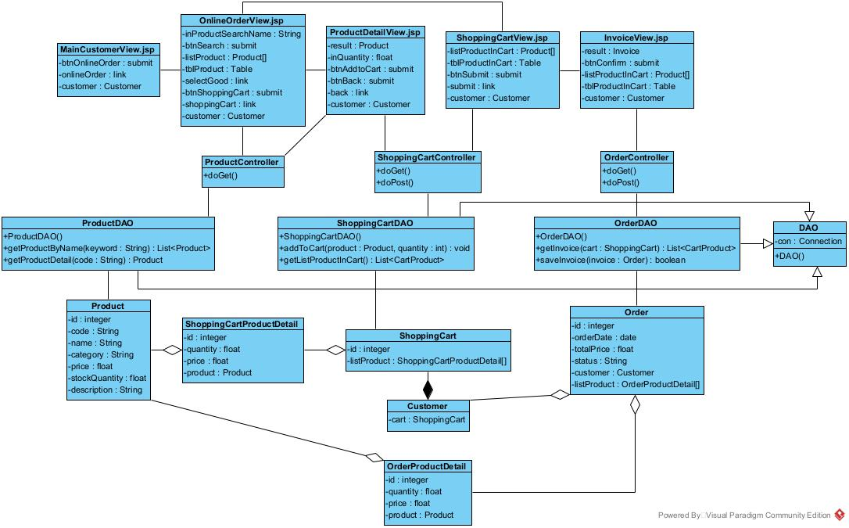

V. Activity diagram of module
1. Module Management Good Information
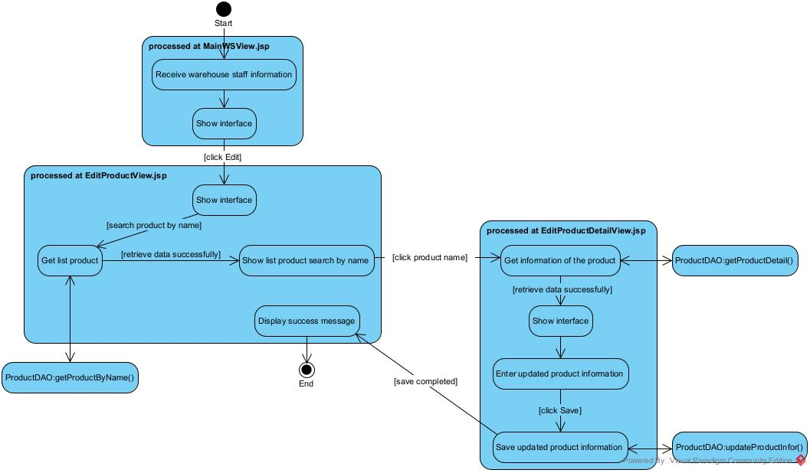

2. Module Order Online
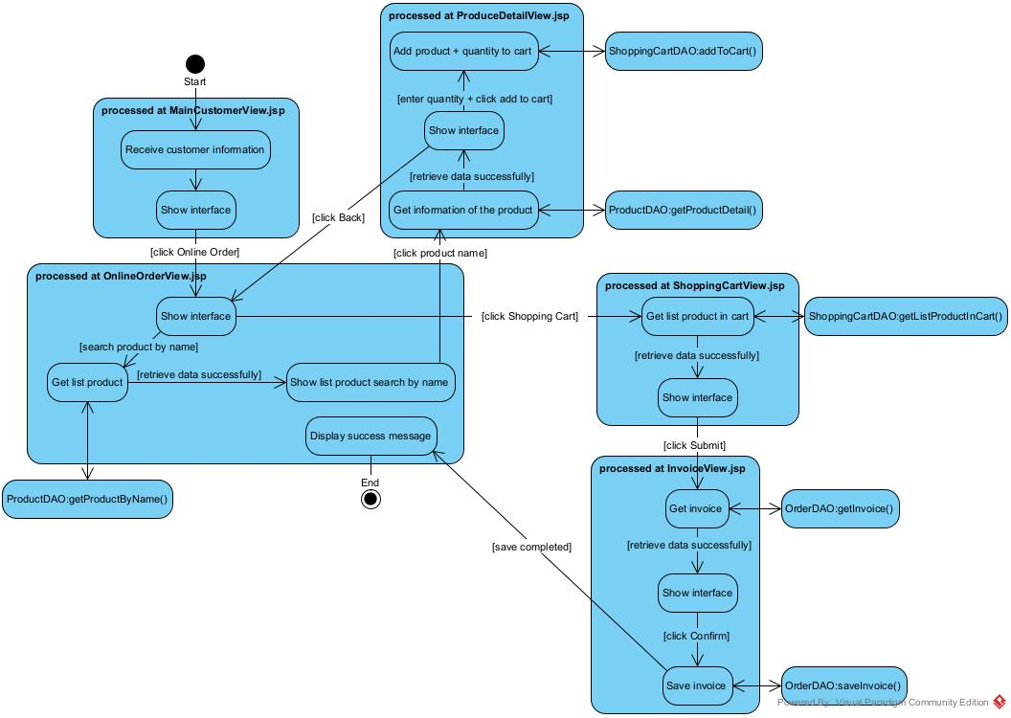
VI. Sequence/communication diagram
1. Scenario v.3:
1.1. Module Management Product Information
1. After logging in, from the main interface, warehouse staff select the Product Management menu.
2. The MainWSView.jsp class displays the list of product management functions.
3. Warehouse staff select Edit Product function.
4. The MainWSView.jsp class calls EditProductView.jsp class.
5. The EditProductView.jsp class displays the interface to the warehouse staff.
6. Warehouse staff enter the product name and click Search.
7. The EditProductView.jsp class calls the ProductController class to retrieve matching products.
8. The ProductController class calls the ProductDAO class.
9. The ProductDAO class calls getProductByName() function.
10. The getProductByName() function executes and calls Product class to retrieve all products that match the search name.
11. The Product class returns to the getProductByName() function.
12. The getProductByName() function returns to ProductController class.
13. The ProductController class returns to EditProductView.jsp class.
14. The EditProductView.jsp class displays the list of matching products to the warehouse staff.
15. Warehouse staff clicks on a product name in the search result table.
16. The EditProductView.jsp class calls the EditProductDetailView.jsp class.
17. The EditProductDetailView.jsp class sends requests to the ProductController class.
18. The ProductController class calls the ProductDAO class to find product details.
19. The ProductDAO class calls getProductDetail() function.
20. The getProductDetail() function executes and calls Product class to package information.
21. The Product class packages product information.
22. The Product class returns results to getProductDetail() function.
23. The getProductDetail() function returns to ProductController class.
24. The ProductController class returns to the EditProductDetailView.jsp class.
25. The EditProductDetailView.jsp class displays the information about the product to the warehouse staff.
26. Warehouse staff edit the information of the product and click Save.
27. The EditProductDetailView.jsp class calls the ProductController class.
28. The ProductController class calls the ProductDAO class to save the updated information.
29. The ProductDAO class calls updateProductInfor() function.
30. The updateProductInfor() function executes and calls Product class to save the changes to the database.
31. The Product class changes the updated product information.
32. The Product class returns results to updateProductInfor() function.
33. The updateProductInfor() function returns to ProductController class.
34. The ProductController class returns to the EditProductView.jsp class.
35. The EditProductView.jsp displays a successful message.
1.2. Module Order Online
1. After logging in, from the main interface, the customer selects the Online Order menu.
2. The MainCustomerView.jsp class calls the OnlineOrderView.jsp class.
3. The OnlineOrderView.jsp class displays the interface to the customer.
4. The customer enters the product name and clicks Search.
5. The OnlineOrderView.jsp class calls the ProductController class to retrieve matching products.
6. The ProductController class calls the ProductDAO class.
7. The ProductDAO class calls the getProductByName() function.
8. The getProductByName() function executes and calls the Product class to retrieve all products that match the search name.
9. The Product class returns the list to the getProductByName() function.
10. The getProductByName() function returns to the ProductController class.
11. The ProductController class returns the list of matching goods to the OnlineOrderView.jsp class.
12. The OnlineOrderView.jsp class displays the list of matching products to the customer.
13. The customer clicks on a product name in the search result list.
14. The OnlineOrderView.jsp class calls the ProductDetailView.jsp class.
15. The ProductDetailView.jsp class sends a request to the ProductController class.
16. The ProductController class calls the ProductDAO class to retrieve detailed product information.
17. The ProductDAO class calls the getProductDetail() function.
18. The getProductDetail() function executes and calls the Product class to package the product information.
19. The Product class packages the information and returns it to the getProductDetail() function.
20. The getProductDetail() function returns to the ProductController class.
21. The ProductController class returns to the ProductDetailView.jsp class.
22. The ProductDetailView.jsp class displays the detailed product information to the customer.
23. The customer reviews the product information, enters the quantity and clicks Add to Cart.
24. The ProductDetailView.jsp class calls the ShoppingCartController class.
25. The ShoppingCartController class calls the ShoppingCartDAO class to add the product and quantity to the shopping cart.
26. The ShoppingCartDAO class calls the addToCart() function.
27. The addToCart() function executes and calls the ShoppingCart class to add the product and quantity.
28. The ShoppingCart class adds to cart and returns the addToCart() function.
29. The addToCart() function returns to the ShoppingCartController class.
30. The ShoppingCartController class returns to the ProductDetailView.jsp class.
31. The ProductDetailView.jsp class displays a successful add-to-cart message.
32. The customer clicks Back.
33. The ProductDetailView.jsp class calls the OnlineOrderView.jsp class.
34. The OnlineOrderView.jsp class displays the interface again to the customer.
35. Steps 4 - 35 are repeated until the customer finishes adding all desired products.
36. The customer clicks the Shopping Cart.
37. The OnlineOrderView.jsp class calls the ShoppingCartView.jsp class.
38. The ShoppingCartView.jsp class calls the ShoppingCartController class.
39. The ShoppingCartController class calls the ShoppingCartDAO class.
40. The ShoppingCartDAO class calls the getListProductInCart() function.
41. The getListProductInCart() function executes and calls the ShoppingCart class.
42. The ShoppingCart class retrieves all products that the customer added to cart and returns to the ShoppingCartDAO class.
43. The ShoppingCartDAO class returns to the ShoppingCartController class.
44. The ShoppingCartController class returns to the ShoppingCartView.jsp class.
45. The ShoppingCartView.jsp class displays the list of products in the cart to the customer.
46. The customer clicks Submit.
47. The ShoppingCartView.jsp class calls the InvoiceView.jsp class.
48. The InvoiceView.jsp class calls the OrderController class.
49. The OrderController class calls the OrderDAO class.
50. The OrderDAO class calls the getInvoice() function.
51. The getInvoice() function executes and calls the Order class to package invoice information.
52. The Order class packages the invoice and returns it to the getInvoice() function.
53. The getInvoice() function returns to the OrderController class.
54. The OrderController class returns to the InvoiceView.jsp class.
55. The InvoiceView.jsp class displays the invoice information to the customer.
56. The customer reviews the invoice and clicks Confirm.
57. The InvoiceView.jsp class calls the OrderController class.
58. The OrderController class calls the OrderDAO class.
59. The OrderDAO class calls the saveInvoice() function.
60. The saveInvoice() function executes and calls the Order class to save the invoice to the database.
61. The Order class saves invoice data to the database and returns to the saveInvoice() function.
62. The saveInvoice() function returns to the OrderController class.
63. The OrderController class returns to the MainCustomerView.jsp class.
64. The MainCustomerView.jsp class displays a successful message to the customer.

2. Sequence diagram
2.1. Module Management Product Information
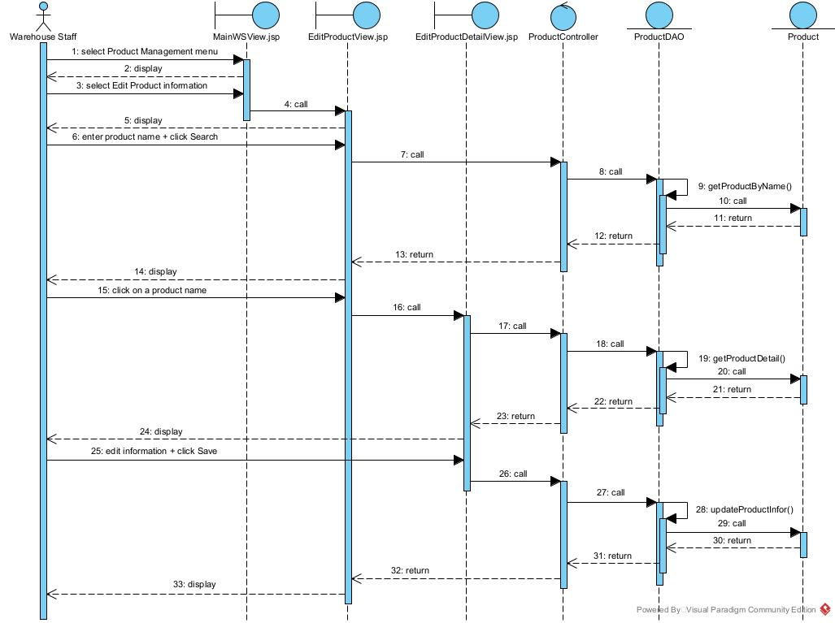

2.2. Module Order Online
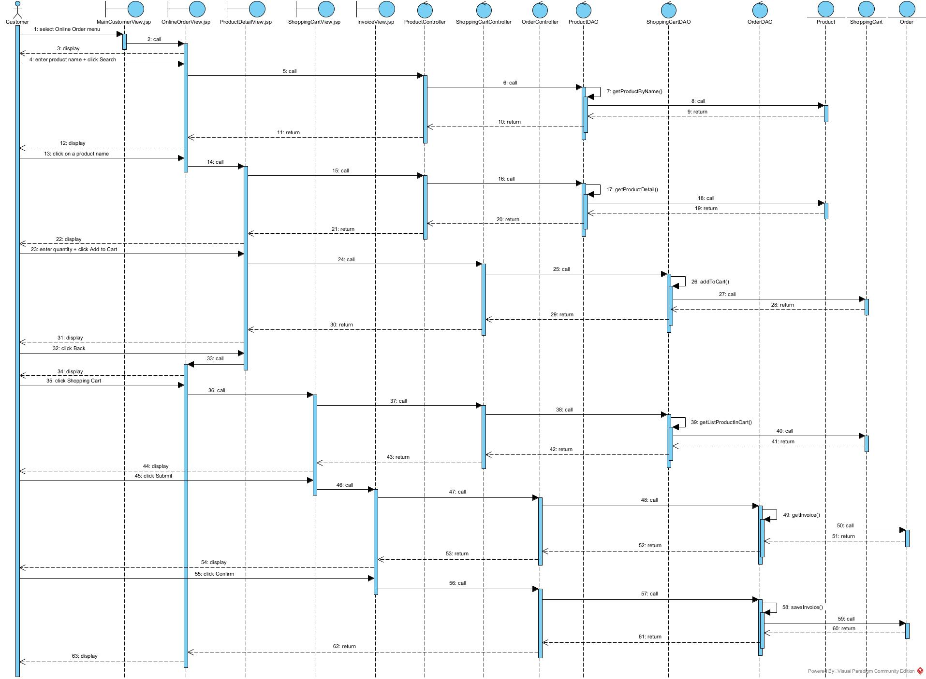

VII. Package and deployment diagram
1. Package
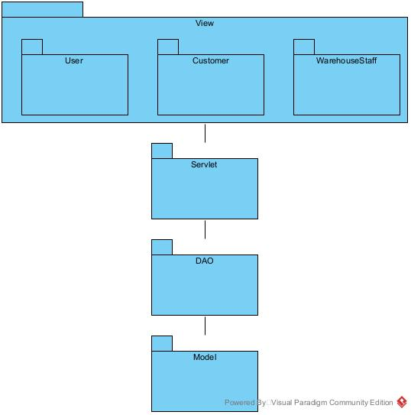
2. Deployment
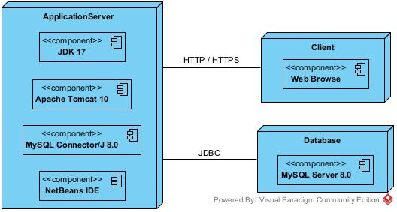
D. IMPLEMENTATION
- Source code:
https://github.com/DungHieu2319/Information-System-Analysis-and-Design---Supermarket-Management-System-08-.git
- System structure:
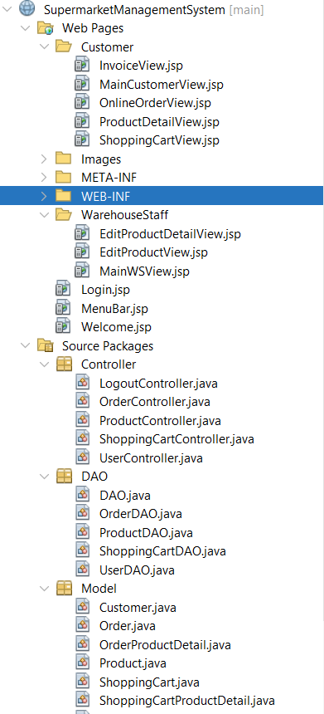
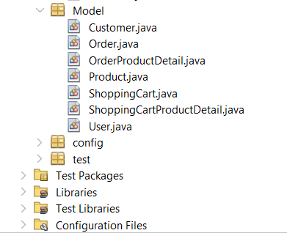

The End

